5

Exploring .NET

In this chapter, we cover the following recipes:

* Exploring .NET assemblies
* Examining .NET classes
* Leveraging .NET methods
* Creating a C# extension
* Creating a PowerShell cmdlet

# Introduction

Microsoft first launched the Microsoft .NET Framework in June 2000, amid a frenzy of marketing zeal, with the code name Next Generation Windows Services. Microsoft seemed to add the .NET moniker to every product. There was Windows .NET Server (renamed Windows Server 2003), Visual Studio.NET, and even MapPoint .NET. As is often the case, over time, .NET provided features which were superseded by later and newer features based on advances in technology. For example, **Simple Object Access Protocol** (**SOAP**) and XML-based web services have given way to **Representation State Transfer** (**REST**) and **JavaScript Object Notation** (**JSON**).

Microsoft made considerable improvements to .NET with each release and added new features in response to customer feedback. .NET started as closed source as the .NET Framework. Microsoft then transitioned .NET to open source, aka .NET Core. PowerShell 7.0 is based on .NET Core 3.1.

An issue was that, over time, .NET became fragmented across different OSes and the web. To resolve this, Microsoft created .NET 5.0 and dropped the “Core” moniker. The intention going forward is to move to a single .NET across all platforms and form factors, thus simplifying application development. See <https://www.zdnet.com/article/microsoft-takes-a-major-step-toward-net-unification-with-net-5-0-release/> for some more details on this.

It is important to note that neither .NET 5.0 nor PowerShell 7.1 have **long-term support** (**LTS**). The next LTS version of .NET is .NET 6.0 and of PowerShell is PowerShell 7.2, both of which are not meant to be released until late in 2021. PowerShell 7.1 is built on top of, and takes advantage of, the latest version of .NET Core, now known as .NET 5.0.

For the application developer, .NET is primarily an **Application Program Interface** (**API**) and a programming model with associated tools and runtime. .NET is an environment in which developers can develop rich applications and websites across multiple platforms.

For IT professionals, .NET provides the underpinnings of PowerShell but is otherwise transparent. You use cmdlets to carry out actions. These cmdlets use .NET to carry out their work without the user being aware there is .NET involved. You can use Get-Process without worrying how that cmdlet actually does its work. But that only gets you so far; there are some important .NET features that have no cmdlets. For example, creating an Active Directory Cross forest trust is done by using the appropriate .NET classes and methods (and is very simple too!). .NET is an important depth tool, helping you to go beyond the cmdlets provided in Windows and Windows applications.

Here is a high-level illustration of the components of .NET:



Figure 5.1: .NET components

**Insert image B42024_05_01.png**

The key components of .NET in this diagram are:

* + - **Operating System**: The .NET story begins with the operating system. The operating system provides the fundamental operations of your computer. .NET leverages the OS components. The .NET team supports .NET 5.0, the basis for PowerShell, on Windows, Linux, and Apple Mac. .NET also runs on the ARM platform, which enables you to get PowerShell on ARM. For a full list of operating systems that support PowerShell 7, see https://github.com/dotnet/core/blob/master/release-notes/5.0/5.0-supported-os.md.
    - **Common Language Runtime (CLR)**: The CLR is the core of .NET, the managed code environment in which all .NET applications run (including PowerShell). The CLR manages memory, threads, objects, resource allocation/de-allocation, and garbage collection. For an overview of the CLR, see https://docs.microsoft.com/dotnet/standard/clr/. For PowerShell users, the CLR “just works”.
    - **Base Class Libraries** **(BCLs)**: .NET comes with a large number of base class libraries, the fundamental built-in features that developers use to build .NET applications. Each BCL is a DLL which contains .NET classes and types. When you install PowerShell, the installer adds the .NET Framework components into PowerShell’s installation folder. PowerShell developers use these libraries to implement PowerShell cmdlets. You can also call classes in the BCL directly from within PowerShell. It is the BCLs that enable you to reach into .NET.
    - **WMI, COM, Win32**: These are traditional application development technologies which you can access via PowerShell. Within PowerShell, you can run programs that use these technologies, as well as access them from the console or via a script. Your scripts can be a mixture of cmdlets, .NET, WMI, COM, and Win32 if necessary.
    - **Languages**: This is the language that a cmdlet and application developer uses to develop PowerShell cmdlets. You can use an extensive variety of languages, based on your preferences and skill set. Most cmdlet developers use C#, although using any .NET supported language would work, such as VB.Net. The original PowerShell development team designed the PowerShell language based on C#. You can describe PowerShell as on the glide scope down to C#. This is useful since there is a lot of documentation with examples in C#.
    - **PowerShell**: PowerShell sits on top of these other components. From PowerShell, you can use cmdlets developed using a supported language, and you can use both BCL and WMI/COM/Win32 as well.

For the most part, moving to .NET 5 with respect to PowerShell is more or less transparent, although not totally. One thing that’s changed in .NET 5 is it drops support for a lot of WinRT APIs. The .NET team did this to boost cross-platform support. However, this means that any module that relied on these APIs, such as the Appx module (https://github.com/PowerShell/PowerShell/issues/13138), is no longer compatible in PowerShell 7.1 (when they were in PS7), although they can be used via the Windows PowerShell compatibility solution described in Chapter 3, Exploring Compatibility with Windows PowerShell.

In this chapter, you examine the assemblies that make up PowerShell 7.1. You then look at both the classes provided by .NET and how to leverage the methods provided by .NET. You also look at creating a simple C# extension and creating a PowerShell cmdlet.

# Exploring .NET assemblies

With .NET, an assembly holds compiled code which .NET can run. An assembly can either be a **Dynamic Link Library** (**DLL**) or an executable. Cmdlets and .NET classes are contained in DLLs, as you see in this recipe. Each assembly also contains a manifest which describes what is in the assembly, along with compiled code.

Most PowerShell modules and commands make use of assemblies of compiled code. When PowerShell loads any module, the module manifest (the .PSD1 file) lists the assemblies which make up the module. For example, the Microsoft.PowerShell.Management module provides many core PowerShell commands, such as Get-ChildItem and Get-Process. This module’s manifest lists a nested module (that is, Microsoft.PowerShell.Commands.Management.dll) as the assembly containing the actual commands.

A great feature of PowerShell is the ability for you to invoke a .NET class method directly or to obtain a static .NET class value. The syntax for calling a .NET method or a .NET field, demonstrated in numerous recipes in this book, is to enclose the class name in square brackets, and then follow it with two colon characters (::), followed by the name of the method or static field.

In this recipe, you examine the assemblies loaded into PowerShell 7 and compare that with the behavior in Windows PowerShell. The recipe illustrates some of the differences between how PowerShell 7 and Windows PowerShell co-exist with .NET. You also look at a module and the assembly that implements the commands in the module.

## Getting ready

You run this recipe on SRV1, a workgroup server on which you have installed PowerShell 7 and VS Code.

## How to do it...

1. Counting loaded assemblies:

$Assemblies = [System.AppDomain]::CurrentDomain.GetAssemblies()

"Assemblies loaded: {0:n0}" -f $Assemblies.Count

1. Viewing the first 10:

$Assemblies | Select-Object -First 10

1. Checking assemblies in Windows PowerShell:

$SB = {

  [System.AppDomain]::CurrentDomain.GetAssemblies()

}

$PS51 = New-PSSession -UseWindowsPowerShell

$AssIn51 = Invoke-Command -Session $PS51 -ScriptBlock $SB

"Assemblies loaded in Windows PowerShell: {0:n0}" -f $Assin51.Count

1. Viewing Microsoft.PowerShell assemblies:

$AssIn51 |

  Where-Object FullName -Match "Microsoft\.Powershell" |

    Sort-Object -Property Location

1. Exploring the Microsoft.PowerShell.Management module:

$Mod = Get-Module -Name Microsoft.PowerShell.Management -ListAvailable

$Mod  | Format-List

1. Viewing the module manifest:

$Manifest = Get-Content -Path $Mod.Path

$Manifest | Select-Object -First 20

1. Discovering the module’s assembly:

Import-Module -Name Microsoft.PowerShell.Management

$Match = $Manifest | Select-String Modules

$Lube = $Match.Line

$DLL = ($Line -Split '"')[1]

Get-Item -Path $PSHOME\$DLL

1. Viewing associated loaded assembly:

$Assemblies2 = [System.AppDomain]::CurrentDomain.GetAssemblies()

$Assemblies2 | Where-Object Location -match $DLL

1. Getting details of a PowerShell command inside a module DLL:

$Commands = $Assemblies2

               Where-Object Location -match Commands.Management\.dll

$Commands.GetTypes() |

  Where-Object Name -match "Addcontentcommand$"

## How it works...

In step 1, you use the GetAssemblies() method to return all the assemblies currently loaded by PowerShell. Then you output a count of the assemblies currently loaded, which looks like this:

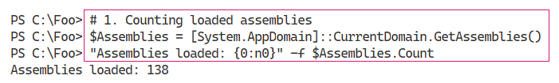

Figure 5.2: Counting the loaded assemblies

Insert image B42024_05_02.png

In step 2, you look at the first 10 assemblies returned, which looks like this:

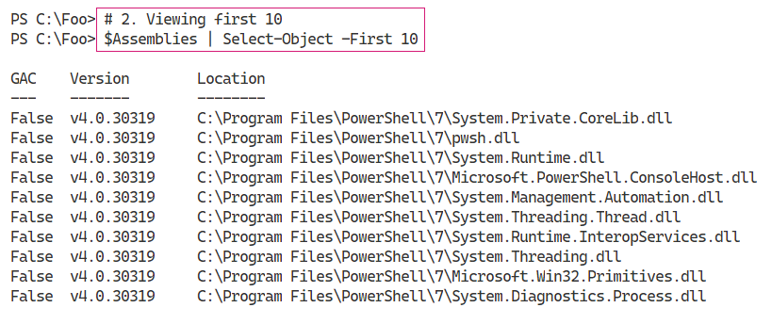

Figure 5.3: Viewing the first 10 assemblies

Insert image B42024_05_03.png

In step 3, you examine the assemblies loaded into Windows PowerShell 5.1, which looks like this:

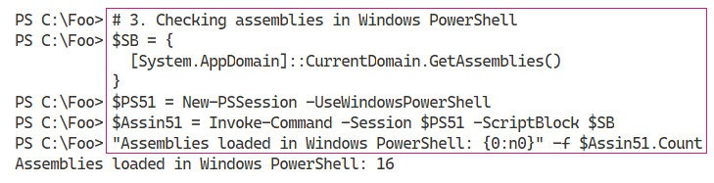

Figure 5.4: Checking the assemblies in Windows PowerShell 5.1

Insert image B42024_05_04.png

With step 4, you examine the Microsoft.PowerShell.* assemblies in PowerShell 5.1, which looks like this:

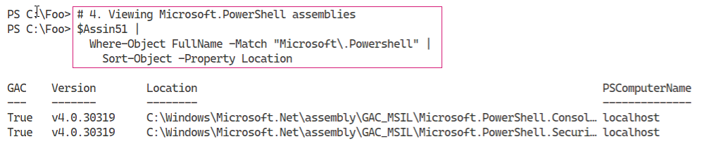

Figure 5.5: Viewing the Microsoft.PowerShell assemblies in Windows PowerShell

Insert image B42024_05_05.png

In step 5, you examine the details of the Microsoft.PowerShell.Management module, which contains numerous core commands in PowerShell. The output of this step looks like this:

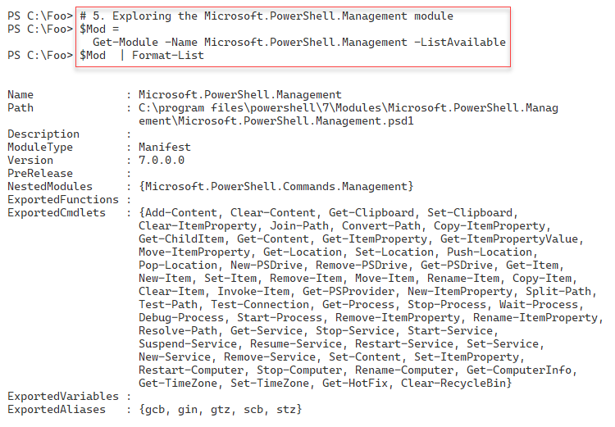

Figure 5.6: Exploring the Microsoft.PowerShell.Management module in PowerShell 7.1

Insert image B42024_05_06.png

In step 6, you view the manifest for the Microsoft.PowerShell.Management module. The following screenshot shows the first 20 lines of the manifest:

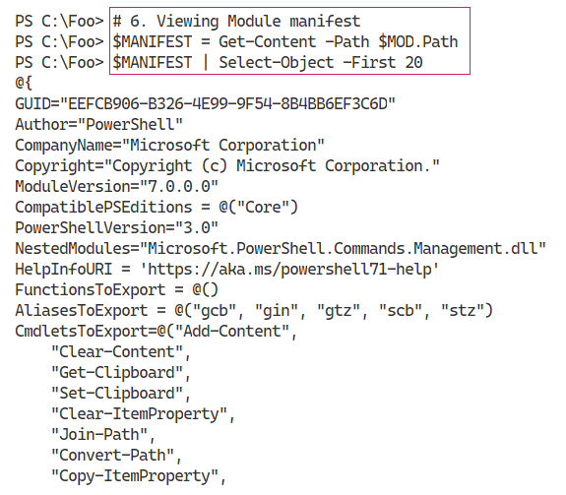

Figure 5.7: Viewing the Microsoft.PowerShell.Management module manifest

Insert image B42024_05_07.png

In step 7, you extract the name of the DLL implementing the Microsoft.PowerShell.Management module and examine the location on disk, which looks like this:

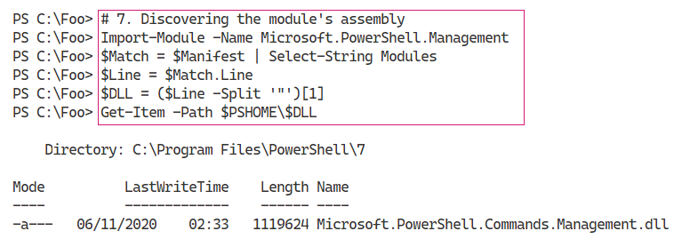

Figure 5.8: Discovering the Microsoft.PowerShell.Management module’s assembly

Insert image B42024_05_08.png

In step 8, you find the assembly that contains the cmdlets in the Microsoft.PowerShell.Management module, which looks like this:

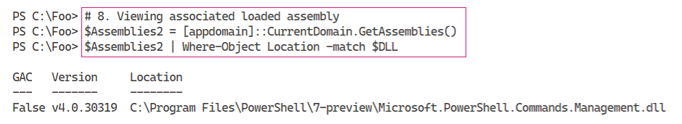

Figure 5.9: Viewing the associated loaded assembly

Insert image B42024_05_09.png

In step 9, you discover the name of the class that implements the Add-Content command, which looks like this:

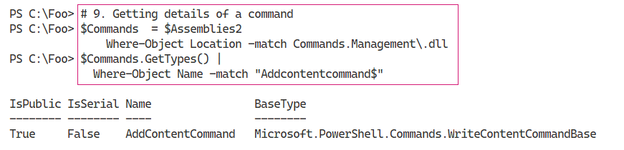

Figure 5.10: Getting details of a command

Insert image B42024_05_10.png

## There’s more...

In this recipe, you have seen the .NET assemblies used by PowerShell. These consist of both the .NET Framework assemblies (that is, the BCLs) and the assemblies which implement PowerShell commands. For example, you find the Add-Content cmdlet in the Microsoft.PowerShell.Management module.

In step 1, you use the GetAssemblies() method to return all the assemblies currently loaded by PowerShell 7.1. As you can see, the syntax is different from calling PowerShell cmdlets.

In steps 3 and 4, you obtain and view the assemblies loaded by Windows PowerShell 5.1. As you can see, different assemblies are loaded by Windows PowerShell.

In step 6, you view the first 20 lines of the module manifest for the Microsoft.PowerShell.Management module. The output cuts off the complete list of cmdlets exported by the module and the long digital signature for the module manifest. In Figure 5.7, you can see that the command Add-Content is implemented within Microsoft.PowerShell.Management.dll.

In step 7, you discover the DLL, which implements inter alia the Add-Content cmdlet and in step 8, you can see that the assembly is loaded. In step 9, you discover that the Add-Content command is implemented by the AddContentCommand class within the assembly’s DLL. For the curious, navigate to https://github.com/PowerShell/PowerShell/blob/master/src/Microsoft.PowerShell.Commands.Management/commands/management/AddContentCommand.cs, where you can read the source code for this cmdlet.

# Examining .NET classes

With .NET, a class defines an object. Objects and object occurrences are fundamental to PowerShell, where cmdlets produce and consume objects. For example, the Get-Process command returns objects of the class System.Diagnostics.Process. If you use Get-ChildItem to return files and folders, the output is a set of objects based on the System.IO.FileInfo and System.IO.DirectoryInfo classes.

In most cases, your console activities and scripts make use of the objects created automatically by PowerShell commands. But you can also use the New-Object command to create occurrences of any class as necessary. This book shows numerous examples of creating an object using New-Object.

Within .NET, you have two kinds of object definitions: .NET classes and .NET types. A type defines a simple object that lives, at runtime, on your CPU’s stack. Classes, being more complex, live in the global heap. The global heap is a large area of memory which .NET uses to hold object occurrences during a PowerShell session. In almost all cases, the difference between type and class is not overly relevant to IT professionals using PowerShell.

After a script or even a part of a script has run, .NET can tidy up the global heap in a process known as garbage collection. The garbage collection process is also not important for IT professionals in most cases. The scripts you see in this book, for example, are not generally impacted by the garbage collection process, nor are most production scripts. For more information on the garbage collection process in .NET, see https://docs.microsoft.com/dotnet/standard/garbage-collection/.

There are cases where the GC process can impact on performance. For example, the System.Array class creates objects of fixed length. If you add an item to an array, .NET creates a new copy of the array (including the addition) and removes the old one. If you are adding a few items to the array, the performance hit is negligible. But if you are adding millions of occurrences, the performance can suffer significantly. To avoid this, you can just use the ArrayList class, which supports adding/removing items from an array without the performance penalty. For more information on GC and performance, see https://docs.microsoft.com/en-us/dotnet/standard/garbage-collection/performance.

.NET 5.0 features many improvements to the garbage collection process. You can read more about the GC improvements in .NET 5.0 here: https://devblogs.microsoft.com/dotnet/performance-improvements-in-net-5/.

In .NET, occurrences of every class or type can include members, including properties, methods, and events. A property is an attribute of an occurrence of a class. An occurrence of the System.IO.FileInfo object, for example, has a FullName property. A method is effectively a function you can call which can do something to an object occurrence. You look at .NET methods in more details in the Leveraging .NET methods recipe. An event is something that can happen to an object occurrence, such when an event is generated when a Windows process has completed. .NET events are not covered in this book, although using WMI events is described in Chapter 15, Managing with Windows Management Instrumentation, in the Managing WMI events recipe.

You can quickly determine an object’s class (or type) by piping the output of any cmdlet, or an object, to the Get-Member cmdlet. The Get-Member cmdlet uses a feature of .NET, reflection, to look inside and give you a definitive statement of what that object contains. This feature is invaluable – instead of guessing where, in some piece of string output, your script can find the full name of a file, you can discover the FullName property, a string, or the Length property, which is unambiguously an integer. Reflection and the Get-Member cmdlet help you to discover the properties and other members of a given object.

.NET classes can have static properties and static methods. Static properties/methods are aspects of the class of a whole as opposed to a specific class instance. A static property is a fixed constant value, such as the maximum and minimum values for a 32-bit signed integer or the value of pi. A static method is one that is independent of any specific instance. For example, the Parse() method of the INT32 class can parse a string to ensure it is a value 32-bit signed integer. In most cases, you use static methods to create object instances or to do something related to the class.

In this recipe, you look at some everyday objects created automatically by PowerShell. You also examine the static fields of the [Int] .NET class.

## Getting ready

You run this recipe on SRV1, a workgroup host running Windows Server Datacenter edition. This host has PowerShell and VS Code installed.

## How to do it...

1. Creating a FileInfo object:

$FILE = Get-ChildItem -Path $PSHOME\pwsh.exe

$FILE

1. Discovering the underlying class:

$TYPE = $FILE.GetType().FullName

".NET Class name: $TYPE"

1. Getting member types of the FileInfo object:

$File |

  Get-Member |

    Group-Object -Property MemberType |

      Sort-Object -Property Count -Descending

1. Discovering properties of a Windows service:

Get-Service |

  Get-Member -MemberType Property

1. Discovering the underlying type of an integer:

$I = 42

$IntType  = $I.GetType()

$TypeName = $IntType.FullName

$BaseType = $IntType.BaseType.Name

".Net Class name      : $TypeName"

".NET Class Base Type : $BaseType"

1. Looking at process objects:

$PWSH = Get-Process -Name pwsh |

  Select-Object -First 1

$PWSH |

  Get-Member |

    Group-Object -Property MemberType |

      Sort-Object -Property Count -Descending

1. Looking at static properties of a class:

$Max = [Int32]::MaxValue

$Min = [Int32]::MinValue

"Minimum value [$Min]"

"Maximum value [$Max]"

## How it works...

In step 1, you use the Get-ChildItem cmdlet to return an object representing the PowerShell 7 executable file, with output like this:

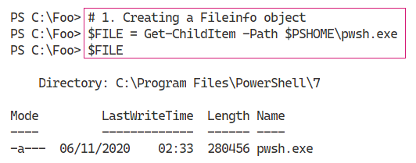

Figure 5.11: Creating a FileInfo object

Insert image B42024_05_11.png

You can determine the class name of an object by using the GetType() method. This method is present on every object and returns information about the object’s type.

In step 2, you discover and display a full class name, which looks like this:

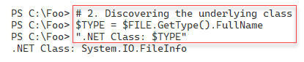

Figure 5.12: Discovering the underlying class

Insert image B42024_05_12.png

In step 3, you use Get-Member to display the different member types contained within a FileInfo object, with output like this:

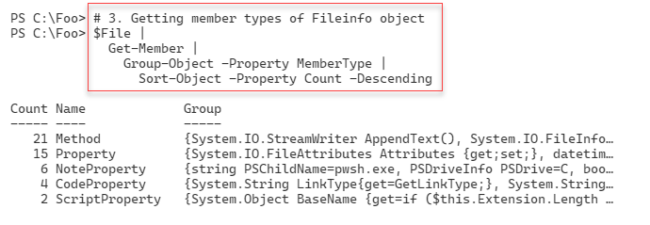

Figure 5.13: Getting member types of the FileInfo object

Insert image B42024_05_13.png

In step 4, you examine objects returned from then Get-Service cmdlet. The output of this step looks like this:

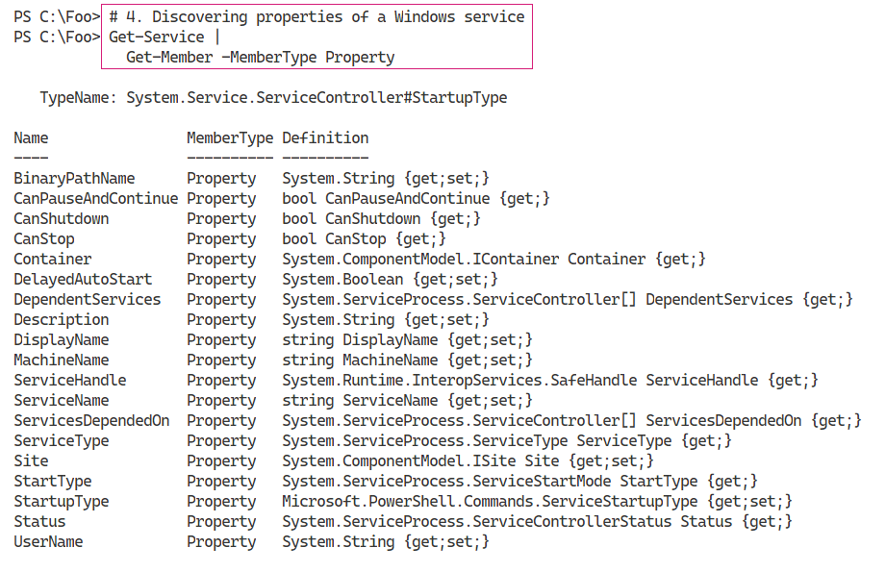

Figure 5.14: Discovering properties of a Windows service

Insert image B42024_05_14.png

In step 5, you examine the details of an integer, a System.Int32 data type. You use the GetType() method, which is present on all .NET objects, to return the variable’s type information, including the full class name of the class. The output looks like this:

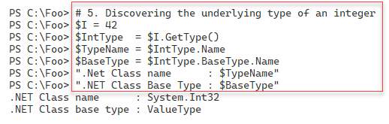

Figure 5.15: Examining type information of an integer

Insert image B42024_05_15.png

In step 6, you examine the member types of a System.Diagnostics.Process object. The Get‑Process cmdlet returns objects of this class. The output of this step looks like this:

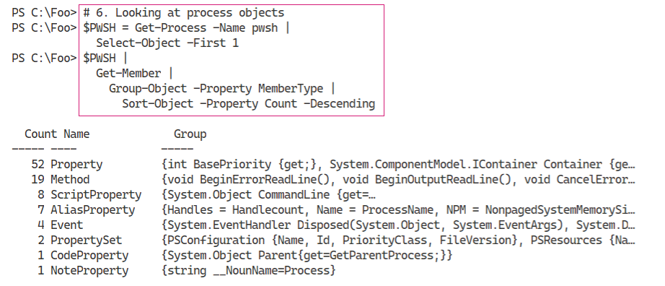

Figure 5.16: Looking at member types of a process object

Insert image B42024_05_16.png

In step 7, you examine two static values of the System.Int32 class. These two fields hold the largest and smallest values, respectively, which a 32-bit signed integer can hold. The output looks like this:

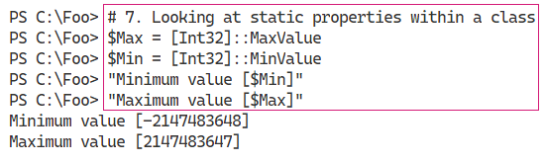

Figure 5.17: Examining static values of the System.Int32 class

Insert image B42024_05_17.png

## There’s more...

In step 1, you create an object representing pwsh.exe. This object’s full type name is System.IO.FileInfo. In .NET, classes live in namespaces and, in general, namespaces equate to DLLs. In this case, the object is in the System.IO namespace, and the class is contained in System.IO.FileSystem.DLL. You can discover namespace and DLL details by examining the class’s documentation – in this case, https://docs.microsoft.com/dotnet/api/system.io.fileinfo?view=net-5.0.

As you use your favourite search engine to learn more about .NET classes that might be useful, note that many sites describe the class without the namespace, simply as the FileInfo class, while others spell out the class as System.IO.FileInfo. If you are going to be using .NET class names in your scripts, a best practice is to spell out the full class name.

# Leveraging .NET methods

With .NET, a method is some action that a .NET object occurrence, or the class, can perform. These methods form the basis for many PowerShell cmdlets. For example, you can stop a Windows process by using the Stop-Process cmdlet. The cmdlet then uses the Kill() method of the associated process object. As a general best practice, you should use cmdlets wherever possible. You should only use .NET classes and methods directly where there is no alternative.

.NET methods can be beneficial for performing operations which have no PowerShell cmdlets. And it can be useful too from the command line; for example, when you wish to kill a process. IT professionals are all too familiar with processes that are not responding and need to be killed, something you can do at the GUI using Task Manager. Or with PowerShell, you can use the Stop-Process cmdlet, as discussed above. At the command line, where brevity is useful, you can use Get-Process to find the process you want to stop and pipe the output to each process’s Kill() method. PowerShell then calls the object’s Kill() method. Of course, to help IT professionals, the PowerShell team created the Kill alias to the Stop-Process cmdlet. In practice, it’s four characters to type versus 12 (or eight if you are using tab completion to its best effect). At the command line, piping to the kill method (where you don’t even have to use the open/close parentheses!) is just faster and risks fewer typos. It is a good shortcut at the command line – but avoid it in production code.

Another great example is encrypting files. Windows supports the NTFS **Encrypting File System** (**EFS**) feature. EFS enables you to encrypt or decrypt files on your computer with the encryption based on X.509 certificates. For details on the EFS and how it works, see https://docs.microsoft.com/ windows/win32/fileio/file-encryption.

At the time of writing, there are no cmdlets to encrypt or decrypt files. The System.IO.FileInfo class, however, has two methods you can use: Encrypt() and Decrypt(). These methods encrypt and decrypt a file based on EFS certificates. You can use these .NET methods to encrypt or decrypt a file without having to use the GUI.

As you saw in the Examining .NET classes recipe, you can pipe any object to the Get-Member cmdlet to discover the methods for the object. Discovering the specific property names and property value types is simple and easy – no guessing or prayer-based text parsing, so beloved by Linux admins.

## Getting ready

You run this recipe on SRV1 after loading PowerShell 7.1 and VS Code.

## How to do it...

1. Starting Notepad:

notepad.exe

1. Obtaining methods on the Notepad process:

$Notepad = Get-Process -Name Notepad

$Notepad | Get-Member -MemberType method

1. Using the Kill() method:

$Notepad |

  ForEach-Object {$_.Kill()}

1. Confirming the Notepad process is destroyed:

Get-Process -Name Notepad

1. Creating a new folder and some files:

$Path = 'C:\Foo\Secure'

New-Item -Path $Path -ItemType directory -ErrorAction SilentlyContinue  |

  Out-Null

1..3 | ForEach-Object {

  "Secure File" | Out-File "$Path\SecureFile$_.txt"

}

1. Viewing files in the $Path folder:

$Files = Get-ChildItem -Path $Path

$Files | Format-Table -Property Name, Attributes

1. Encrypting the files:

$Files| ForEach-Object Encrypt

1. Viewing file attributes:

Get-ChildItem -Path $Path |

  Format-Table -Property Name, Attributes

1. Decrypting and viewing the files:

$Files| ForEach-Object {

  $_.Decrypt()

}

Get-ChildItem -Path $Path |

  Format-Table -Property Name, Attributes

## How it works...

In step 1, which produces no output, you start Notepad.exe. This creates a process which you can examine and use.

In step 2, you obtain Notepad’s process object and examine the methods available to you. The output looks like this:

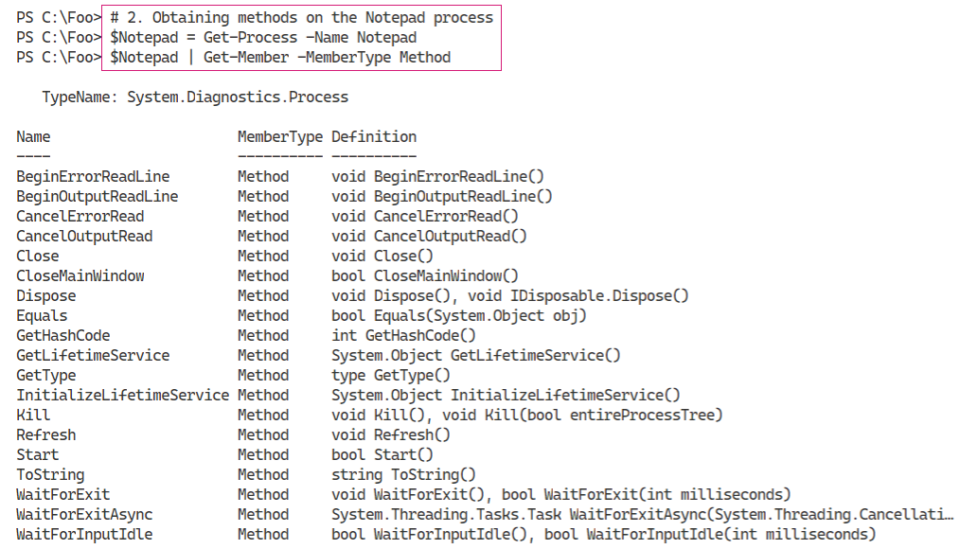

Figure 5.18: Examining methods on the Notepad process

Insert image B42024_05_18.png

In step 3, you use the Kill() method in the System.Diagnostics.Process object to stop the Notepad process. This step produces no output. In step 4, you confirm that you have stopped the Notepad process, with output like this:

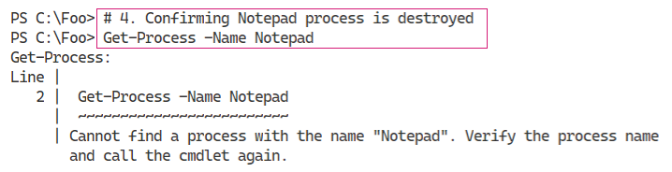

Figure 5.19: Confirming the Notepad process has been destroyed

Insert image B42024_05_19.png

To illustrate other uses of .NET methods, you create a folder and three files within the folder in step 5. Creating these files generates no output. In step 6, you use the Get-ChildItem cmdlet to retrieve details about these three files, including all file attributes, which looks like this:

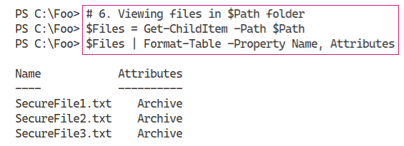

Figure 5.20: Viewing the files in the $Path folder

Insert image B42024_05_20.png

In step 7, you use the encrypt method to encrypt the files, generating no output at the command line. In step 8, you view again the attributes of the files, which looks like this:

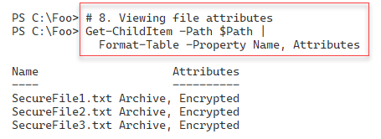

Figure 5.21: Viewing the file attributes

Insert image B42024_05_21.png

Finally, with step 9, you decrypt the files using the Decrypt() method. You then use the Get‑ChildItem cmdlet to view the file attributes, which allows you to determine that the files are not encrypted. The output of this step looks like this:

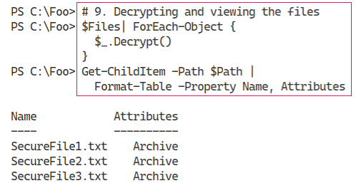

Figure 5.22: Decrypting and viewing the file attributes again

Insert image B42024_05_22.png

## There’s more...

In step 2, you view the methods you can invoke on a process object. One of those methods is the Kill() method, as you can see in *Figure 5.18*. In step 3, you use that method to stop the Notepad process. The Kill() method is an instance method, meaning you invoke it to kill (stop) a specific process. You can read more about this .NET method at https://docs.microsoft.com/dotnet/api/system.diagnostics.process.kill.

The output in step 4 illustrates an error occurring within VS Code. If you use the PowerShell 7 console, you may see slightly different output, although with the same actual error message.

In steps 7 and 9, you use the FileInfo objects (created by Get-ChildItem) and call the Encrypt() and Decrypt() methods. These steps demonstrate using .NET methods to achieve some objective in the absence of specific cmdlets. Best practice suggests always using cmdlets where you can. You should also note that the syntax in the two steps is different. In step 7, you use a more modern syntax which calls the Encrypt method for each file. In step 9, you use an older syntax that does the same thing, albeit with more characters. Both syntax methods work.

In step 7, while you get no console output, Windows may generate a popup (aka Toast) to tell you that you should back up your encryption key. This is a good idea because if you lose the key, you could lose all access to the file.

# Creating a C# extension

For most day-to-day operations, the commands provided by PowerShell from Windows features, or third-party modules, give you all the functionality you need. In some cases, as you saw in the Leveraging .NET methods recipe, commands do not exist to achieve your goal. In those cases, you can make use of the methods provided by .NET.

There are also cases where you need to perform more complex operations without PowerShell cmdlet or direct .NET support. You may, for example, have a component of an ASP.NET web application, written in C# but which you now wish to repurpose for administrative scripting purposes.

PowerShell makes it easy to add a class, based on .NET language source code, into a PowerShell session. You supply the C# code, and PowerShell creates a .NET class that you can use in the same way you use .NET methods (and using virtually the same syntax). To do this, you use the Add-Type cmdlet and specify the C# code for your class/type(s). PowerShell compiles the code and loads the resultant class into your PowerShell session.

An essential aspect of .NET methods is that a method can have multiple definitions or calling sequences. Known as method overloads, these multiple definitions allow you to invoke a method using different sets of parameters. This is not dissimilar to PowerShell’s use of parameter sets. For example, the System.String class, which PowerShell uses to hold strings, contains the Trim() method. You use that method to remove extra characters, usually space characters, from the start or end of a string (or both). The Trim() method has three different definitions, which you view in this recipe. Each overloaded definition trims characters from a string slightly differently. To view more details on this method, and the three overloaded definitions, see https://docs.microsoft.com/dotnet/api/system.string.trim?view=net-5.0/.

In this recipe, you create and use two simple classes, each with static methods.

## Getting ready

You run this recipe on SRV1, a workgroup system running Windows Server Datacenter edition. You must have loaded PowerShell 7 and VS Code onto this host.

## How to do it...

1. Examining the overloaded method definition:

("a string").Trim

1. Creating a C# class definition in a here-string:

$NewClass = @"

namespace Reskit {

   public class Hello {

     public static void World() {

         System.Console.WriteLine("Hello World!");

     }

   }

  }

"@

1. Adding the type into the current PowerShell session:

Add-Type -TypeDefinition $NewClass

1. Examining the method definition:

[Reskit.Hello]::World

1. Using the class’s method:

[Reskit.Hello]::World()

1. Extending the code with parameters:

$NewClass2 = @"

using System;

using System.IO;

namespace Reskit {

  public class Hello2  {

    public static void World() {

      Console.WriteLine("Hello World!");

    }

    public static void World(string name) {

      Console.WriteLine("Hello " + name + "!");

    }

  }

}

"@

1. Adding the type into the current PowerShell session:

Add-Type -TypeDefinition $NewClass2 -Verbose

1. Viewing method definitions:

[Reskit.Hello2]::World

1. Calling new method with no parameters specified:

[Reskit.Hello2]::World()

1. Calling new method with a parameter:

[Reskit.Hello2]::World('Jerry')

## How it works...

In step 1, you examine the different method definitions for the Trim() method. The output, showing the different overloaded definitions, looks like this:

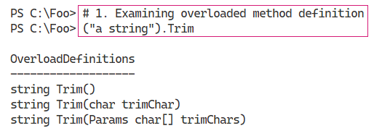

Figure 5.23: Examining different method definitions for Trim()

Insert image B42024_05_23.png

In step 2, you create a class definition and store the definition in a variable. In step 3, you add this class definition into your current PowerShell workspace. These two steps produce no output.

In step 4, you use the new method to observe the definitions available to you, which looks like this:

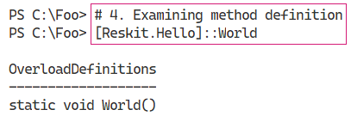

Figure 5.24: Examining method definitions

Insert image B42024_05_24.png

In step 5, you use the World() method, whose output is as follows:

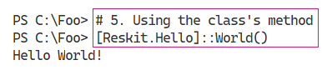

Figure 5.25: Using the World() method

Insert image B42024_05_25.png

In steps 6 and 7, you create another new class definition, this time with two overloaded definitions to the World() method. These two steps produce no output. In step 8, you view the definitions for the World() method within the Reskit.Hello2 class, with output like this:

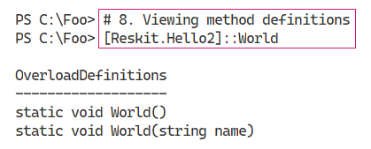

Figure 5.26: Viewing the World() method definitions

Insert image B42024_05_26.png

In step 9, you invoke the World() method, specifying no parameters, which produces this output:

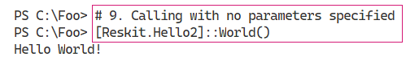

Figure 5.27: Calling World() with no parameters specified

Insert image B42024_05_27.png

In step 10, you invoke the World() method, specifying a single string parameter, which produces this output:

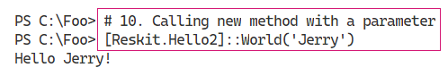

Figure 5.28: Calling World() while specifying a single string parameter

Insert image B42024_05_28.png

## There’s more...

In step 1, you examine the different definitions of a method – in this case, the Trim() method of the System.String class. There are several ways you discover method overloads. In this step, you create a pseudo-object containing a string and then look at the method definitions. PowerShell creates an unnamed object (in the .NET managed heap) which it immediately destroys after the statement completes. At some point later in time, .NET runs the GC process to reclaim the memory used by this temporary object and reorganizes the managed heap.

As you can see, there are three overloaded definitions – three different ways you can invoke the Trim() method. You use the first overloaded definition to remove both leading and trailing space characters from a string, probably the most common usage of Trim(). With the second definition, you specify a specific character and .NET removes any leading or trailing occurrences of that character. With the third definition, you specify an array of characters to trim from the start or end of the string. In most cases, the last two definitions are less useful, although it depends on your use cases. The extra flexibility is useful.

In step 3, you use the Add-Type cmdlet to add the class definition into your current workspace. The cmdlet compiles the C# code, creates, and then loads a DLL, which then enables you to use the classes. If you intend to use this add-in regularly, then you could add steps 2 and 3 into your PowerShell profile file or a production script. Alternatively, if you use this method within a script, you could add the steps into the script.

As you can see from the C# code in step 6, you can add multiple definitions to a method. With the classes within .NET and its BCLs, or in your own code, overloaded methods can provide a great deal of value. The .NET method documentation, which you can find at https://docs.microsoft.com, is mainly oriented toward developers rather than IT professionals. If you have issues with a .NET method, feel free to fire off a query on one of the many PowerShell support forums, such as the PowerShell group at Spiceworks: https://community.spiceworks.com/programming/powershell.

# Creating a PowerShell cmdlet

As noted previously, for most operations, the commands and cmdlets available to you natively provide all the functionality you need (in most cases). In the Creating a C# extension recipe, you saw how you could create a class definition and add it into PowerShell. In some cases, you may wish to expand on the class definition and create your own cmdlet.

Creating a compiled cmdlet requires you to either use a tool such as Visual Studio or use the free tools provided by Microsoft as part of the .NET Core **Software Development Kit (SDK**). Visual Studio, whether the free community edition or the commercial releases, is a rich and complex tool whose inner workings are well outside the scope of this book. The free tools in the SDK are more than adequate to help you create a cmdlet using C#.

As in the Creating a C# extension recipe, an important question to ask is: why and when should you create a cmdlet? Aside from the perennial “because you can” excuse, there are reasons why an extension or a cmdlet might be a good idea. You can create a cmdlet to improve performance – for some operations, a compiled cmdlet is just faster than doing operations using a PowerShell script. For some applications, using a cmdlet is to perform actions that are difficult or not possible directly in PowerShell, including asynchronous operations and the use of a **Language Independent Query** (**LINQ**). A developer could write the cmdlet in C#, allowing you to use it easily with PowerShell.

In order to create a cmdlet, you need to install the Windows SDK. The SDK contains all the tools you need to create a cmdlet. The SDK is a free download you get via the internet.

In this recipe, you load the Windows SDK and use it to create a new PowerShell cmdlet. The installation of the .NET SDK requires you to navigate to a web page, download, and then run the SDK installer.

## Getting ready

You run this recipe on SRV1, a workgroup system running Windows Server Datacenter edition. You must have loaded PowerShell 7 and VS Code onto this host.

## How to do it...

1. Installing the .NET 5.0  SDK:

Open your browser, navigate to https://dotnet.microsoft.com/download/, and follow the GUI to download and run the SDK installer. You can see this process in the *How it works…* section below.

1. Creating the cmdlet folder:

New-Item -Path C:\Foo\Cmdlet -ItemType Directory -Force

Set-Location C:\Foo\Cmdlet

1. Creating a new class library project:

dotnet new classlib --name SendGreeting

1. Viewing contents of the new folder:

Set-Location -Path .\SendGreeting

Get-ChildItem

1. Creating and displaying the global.json file:

dotnet new globaljson

Get-Content .\global.json

1. Adding the PowerShell package:

dotnet add package PowerShellStandard.Library

1. Creating the cmdlet source file:

$Cmdlet = @"

using System.Management.Automation;  // Windows PowerShell assembly.

namespace Reskit

{

  // Declare the class as a cmdlet

  // Specify verb and noun = Send-Greeting

  [Cmdlet(VerbsCommunications.Send, "Greeting")]

  public class SendGreetingCommand : PSCmdlet

  {

    // Declare the parameters for the cmdlet.

    [Parameter(Mandatory=true)]

    public string Name

    {

      get { return name; }

      set { name = value; }

    }

    private string name;

    // Override the ProcessRecord method to process the

    // supplied name and write a greeting to the user by

    // calling the WriteObject method.

    protected override void ProcessRecord()

    {

      WriteObject("Hello " + name + " - have a nice day!");

    }

  }

}

"@

$Cmdlet | Out-File .\SendGreetingCommand.cs

1. Removing the unused class file:

Remove-Item -Path .\Class1.cs

1. Building the cmdlet:

dotnet build

1. Importing the DLL holding the cmdlet:

$DLLPath = '.\bin\Debug\net5.0\SendGreeting.dll'

Import-Module -Name $DLLPath

1. Examining the module’s details:

Get-Module SendGreeting

1. Using the cmdlet:

Send-Greeting -Name "Jerry Garcia"

## How it works...

In step 1, you open your browser and navigate to the .NET Download page, which looks like this:

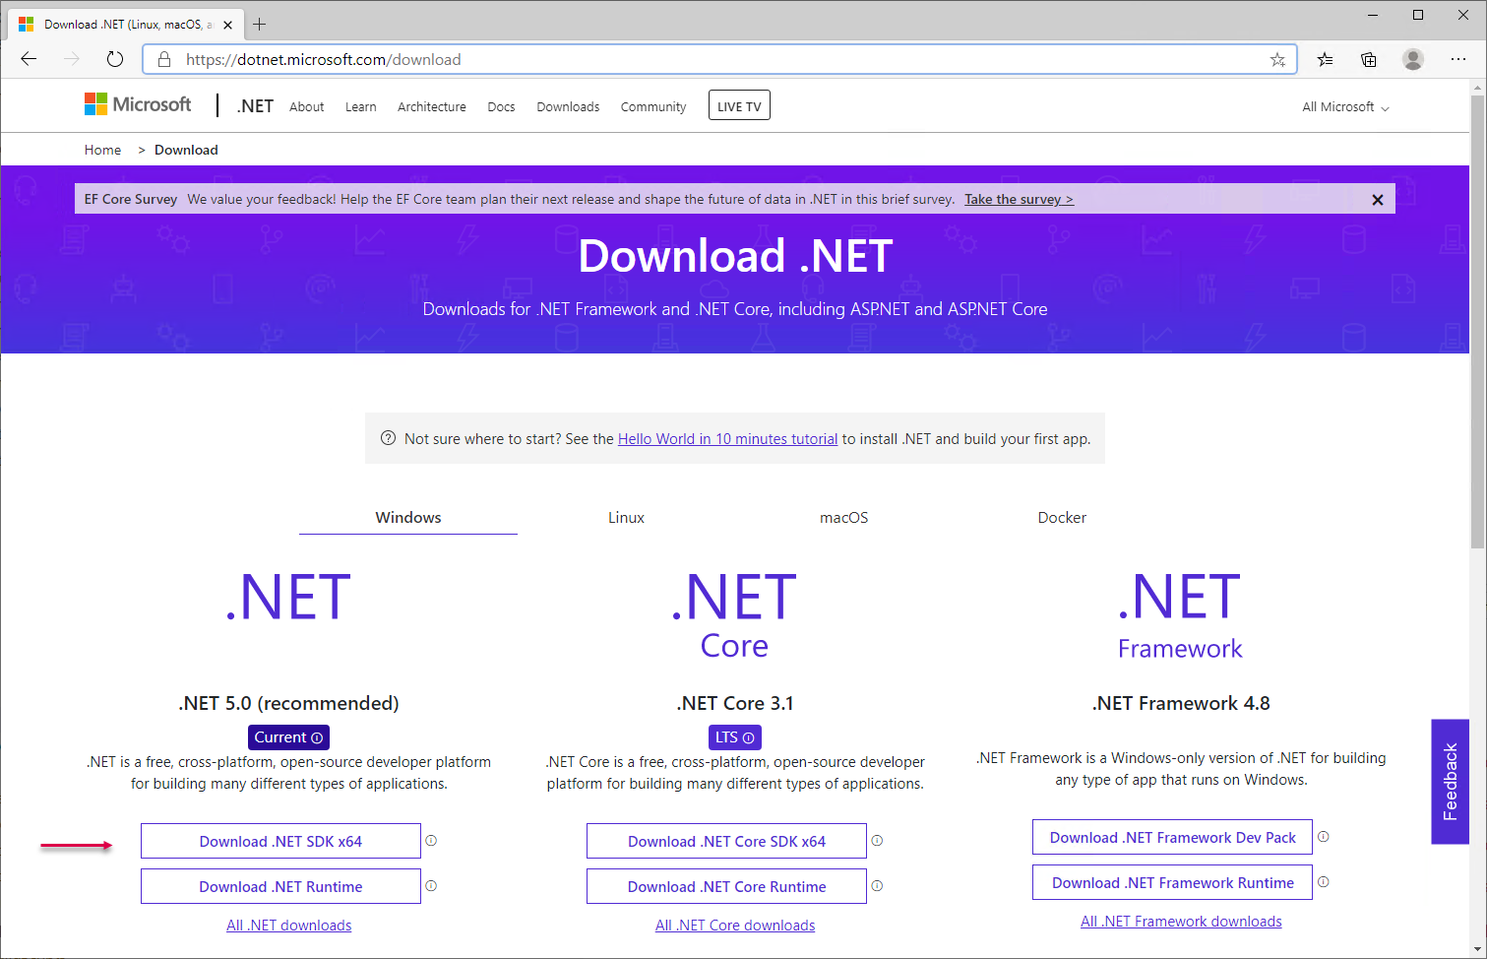

Figure 5.29: The .NET Download page

Insert image B42024_05_29.png

Click, as shown, on the link to Download the .NET SDK X64 to download the .NET SDK installer program. Ensure you download the .NET 5.0 SDK - which looks like this:

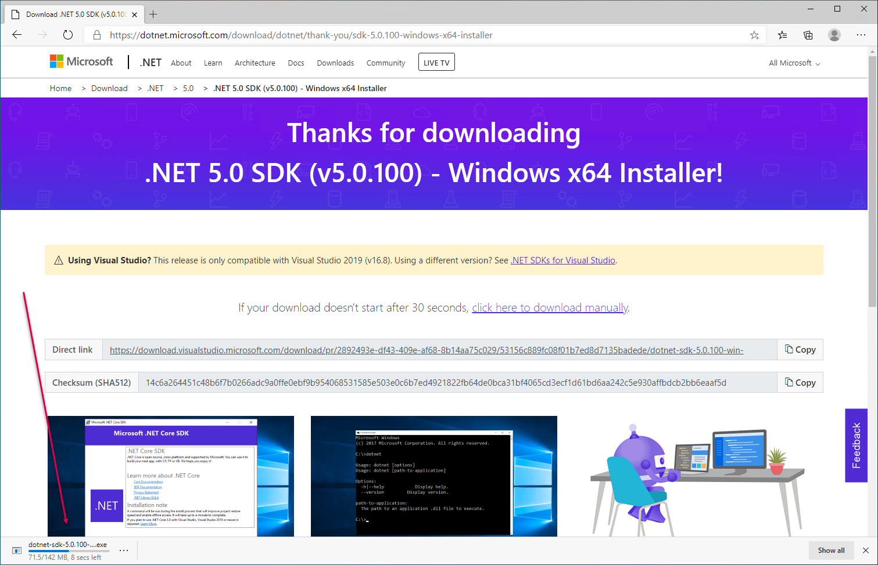

Figure 5.30: Downloading the .NET SDK installer

Insert image B42024_05_30.png

The installer program is around 150 MB, so it may take a while to download, depending on your internet connection speed. When the download is complete, you see the download indication look like this:

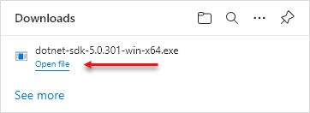

Figure 5.31: Installer download complete

Insert image B42024_05_31.png

If you click on the Open file link, you launch the installer and see the installer’s opening page:

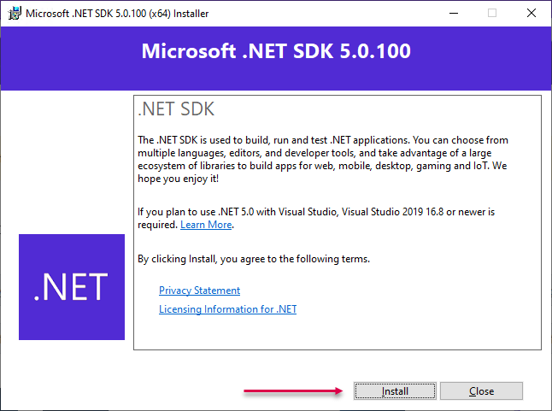

Figure 5.32: The .NET SDK installer

Insert image B42024_05_32.png

When you click on the Install button, as shown, the installer program completes the setup of the .NET SDK. When setup is complete, you see the final screen:

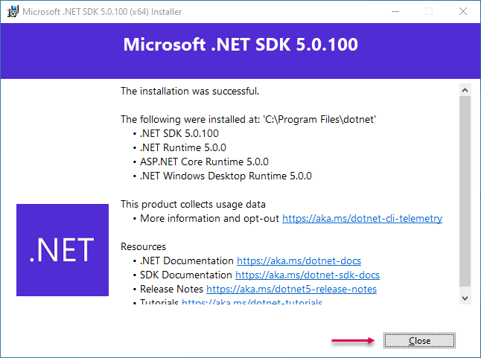

Figure 5.33: Installation successful screen

Insert image B42024_05_33.png

Click on Close to complete the setup. If you had a PowerShell console (or VS Code) open when you did the SDK installation, close then reopen it. The installer updates your system’s Path variable so you can find the tools, which requires a restart of PowerShell to take effect.

In step 2, you create a new folder to hold your new cmdlet and use Set-Location to move into that folder. The output from this step looks like this:

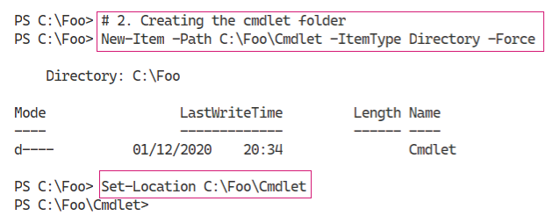

Figure 5.34: Creating the cmdlet folder and moving into it

Insert image B42024_05_34.png

In step 3, you create a new class library project using the dotnet.exe command, which looks like this:

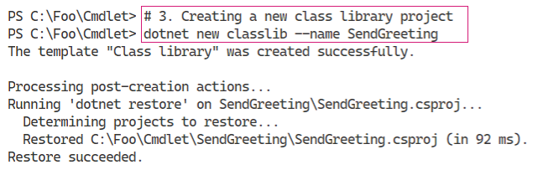

Figure 5.35: Creating a new class library project

Insert image B42024_05_35.png

In step 4, you view the contents of the folder created by the previous step. The output looks like this:

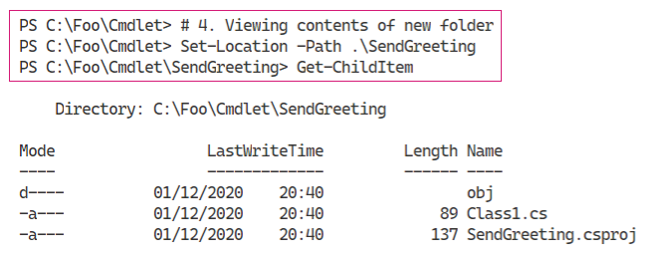

Figure 5.36: Viewing the contents of the new folder

Insert image B42024_05_36.png

In step 5, you create and then view a new global.json file. This JSON file, among other things, specifies which version of .NET is to be used to build your new cmdlet. The output of this step looks like this:

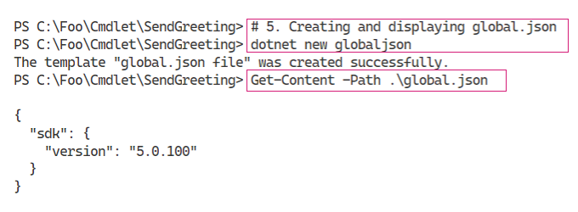

Figure 5.37: Creating and displaying a new global.json file

Insert image B42024_05_37.png

In step 6, you add the PowerShell package to your project. This step enables you to use the classes in the package to build your cmdlet. The output looks like this:

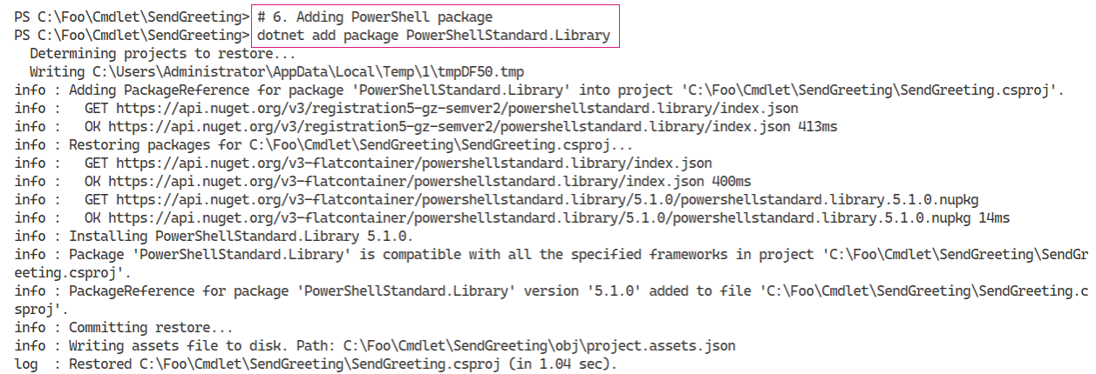

Figure 5.38: Adding the PowerShell package

Insert image B42024_05_38.png

In step 7, you use PowerShell and a here-string to create the source code file for your new cmdlet. This step produces no output.

In step 3, you create your new project. This step also creates a file called Class1.cs, which is not needed for this project. In step 8, which generates no output, you remove this unneeded file.

In step 9, you build the cmdlet, which produces output like this:

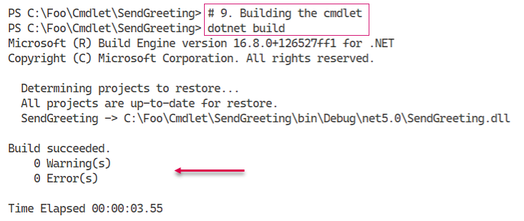

Figure 5.39: Building the cmdlet

Insert image B42024_05_39.png

In step 10, you use Import-Module to import the DLL, which produces no output. With step 11, you use Get-Module to discover the imported module (containing just a single command), which looks like this:

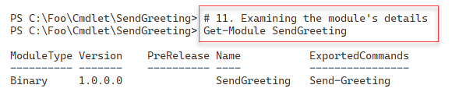

Figure 5.40: Examining the imported module

Insert image B42024_05_40.png

In the final step in the recipe, step 12, you execute the cmdlet, which produces the following output:

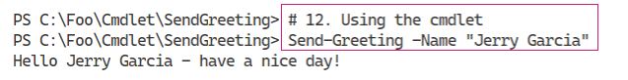

Figure 5.41: Using the cmdlet

Insert image B42024_05_41.png

## There’s more...

In step 1, you download the .NET SDK, which you need in order to create a cmdlet. There appears to be no obvious way to automate the installation, so you need to run the installer and click through its GUI in order to install the .NET SDK.

The ./NET SDK should be relatively straightforward to install, as shown in this recipe. You download and run the .NET installer and are then able to use the tools to build a cmdlet. But in a few, thankfully rare, cases the installation may not work correctly and/or the installer may get confused. You may need to uninstall any other SDKs you have loaded or perhaps enquire on a support forum such as <https://community.spiceworks.com/programming/powershell>. That being said, you should not have this problem on a newly created VM.

In step 3, you create a new class library project. This step also creates the SendGreeting.csproj file, as you can see. This file is a Visual Studio .NET C# project file that contains details about the files included in your Send-Greeting cmdlet project, assemblies referenced from your code, and more. For more details on the project file, see https://docs.microsoft.com/en-us/aspnet/web-forms/overview/deployment/web-deployment-in-the-enterprise/understanding-the-project-file.

In step 5, you create the global.json file. If you do not create this file, the dotnet command will compile your cmdlet with the latest version of .NET Core loaded on your system. Using this file tells the project build process to use a specific version of .NET Core (such as version 5.0). For an overview to this file, see https://docs.microsoft.com/dotnet/core/tools/global-json.

In step 9, you compile your source code file and create a DLL containing your cmdlet. This step compiles all of the source code files contained in the folder to create the DLL. This means you could have multiple cmdlets, each in a separate source code file, and build the entire set in one operation.

In step 11, you can see that the module, SendGreeting, is a binary module. A binary module is one just loaded directly from a DLL. This is fine for testing, but in production, you should create a manifest module by adding a manifest file. You can get more details on manifest files from https://docs.microsoft.com/en-us/powershell/scripting/developer/module/how-to-write-a-powershell-module-manifest?view=powershell-7.1. You should also move the module and manifest, and any other module content such as help files, to a supported module location. You might also consider publishing the completed module to either the PowerShell gallery or to an internal repository.